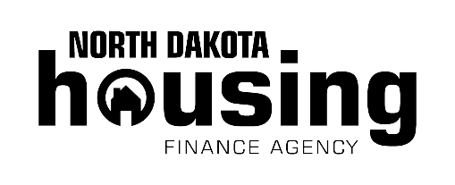

**For more details visit www.ndhfa.org.**

**What is HomeAccess?**

Through its HomeAccess program, NDHFA provides single parents, veterans and families with disabled or elderly household members with affordable financing and down payment and closing cost assistance.

**How to qualify**

One of the following must describe the household:

* You must be a single parent with at least one dependent child residing in the home 50 percent of the time.
* You or your spouse must have served in the active military, naval or air service and been discharged or released from active duty under conditions other than dishonorable.
* You, your spouse, or your dependent(s) must be permanently disabled or age 65 or older and reside in the home.
* You must meet income and purchase price limits.

**Down payment and closing cost assistance**

* Assistance equals 3 percent.

Get Started!

*Agent Name Here*

NDHFA FirstHome Certified Agent

*Additional contact information*

North Dakota Housing Finance Agency (NDHFA) offers affordable financing and the ability to receive down payment and closing cost assistance to certain homebuyers who are looking to purchase another home as their primary residence. Contact one of NDHFA’s participating lenders to learn about HomeAccess.

Move On To Your Next Home

Rev. 3/22

Disclaimer: North Dakota Housing Finance Agency uses approved lenders to qualify customers and make all mortgage loans.