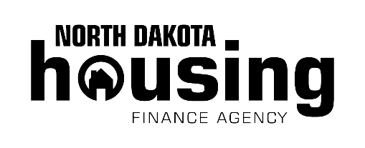

**For more details visit www.ndhfa.org.**

Affordable Home Financing

Get Started!

*Lender Name Here*NDHFA Participating Lender  
  
*Additional contact information*

**NDHFA’s statewide network of participating lenders offer:**

* Mortgage loans for your first home, your next home or to refinance.

**General program requirements**

* $500 out-of-pocket cash investment.
* You must occupy the home as your principal residence.
* Household income must be below a specific income limit according to family size, county of residence and program requirements.

**Down payment and closing cost assistance**

* Assistance equals 3 percent of the mortgage amount.
* NDHFA-approved homebuyer education may be required.

Rev. 3/22

Disclaimer: North Dakota Housing Finance Agency uses approved lenders to qualify customers and make all mortgage loans.

North Dakota Housing Finance Agency’s (NDHFA) mortgage programs are an excellent choice with our low down payment requirements. Set yourself up for successful homeownership by talking to one of NDHFA’s participating lenders today to determine which option is best for you.