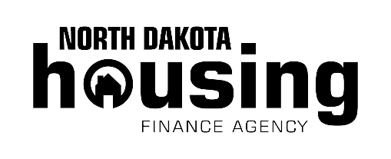

If you want to become a homeowner or are looking to purchase a different home, but you don’t have enough cash for the down payment or to cover closing costs, North Dakota Housing Finance Agency (NDHFA) may be able to help. Combined with our mortgage programs, getting a boost to cover upfront costs, can bring you one step closer to owning a new home. Set yourself up for success. Talk to a participating lender today.

**For more details visit www.ndhfa.org.**

Need a Homebuying Boost?

Get Started!

*Agent Name Here*NDHFA FirstHome Certified Agent  
  
*Additional contact information*

Rev. 3/22

**Down payment and closing cost assistance**

NDHFA provides affordable mortgage loans that include down payment and closing cost assistance. These extra funds can help with out-of-pocket costs, helping homebuyers to achieve ownership sooner.

* Assistance equals 3 percent of the mortgage amount.
* NDHFA-approved homebuyer class may be required.
* Available for one- or two-unit properties (one unit must be occupied by the borrower).
* Cannot be used in conjunction with other assistance programs.
* Eligibility is determined by income limits, which vary based on the county where you will live and your household size.

Disclaimer: North Dakota Housing Finance Agency uses approved lenders to qualify customers and make all mortgage loans.